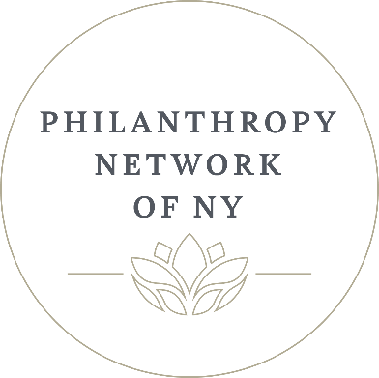
Sponsorship/Membership Application

Please reserve the following Sponsorship/Membership package for ________________________________________________ (Company Name)

____Benefactor $7,500 ____ Supporter $5,000 ____ Steward $1,000

Sponsorships are valid for one year. Starting from when application/payment is received by Philanthropy Network of NY.
MEMBERSHIP RATES 2023
(Additional Administration Fee of $20.00 per registrant/per event) **
____$2,900 Membership** (Company < 10) ____$3,900 Membership**

*********************************************************************************************
PLEASE COMPLETE PAYMENT AND CONTACT INFORMATION BELOW
Method of Payment (please check one):

( ) Check in the amount of $ _________________ ( ) Check enclosed
( ) Please charge $ _____________ to Credit Card # ______________________________
Exp Date _________ CVV ________ AMEX ( ) VISA ( ) MC ( )

Name on Credit Card_______________________________________________________
Billing Address___________________________________________________________
City _______________________________ State __________ Zip Code______________
Signature________________________________________________________________
Federal I.D. # 92-2575440

Date Received by PNNEWYORK _ _______________________
*Please note all payments made via credit card have a 4% convenience fee added to the invoice
Name of Organization ___________________________________________________
Contact Person __________________________________Title ___________________

Phone ________________________ Email_________________________________

Address ______________________________ City __________________ Zip ______

Please make check payable to: Philanthropy Network of New York or Email this form to liz@pnnewyork.com or mail to: PNNEWYORK: 10 Angelica Court, Hauppauge, NY 11787
For additional information please email: liz@pnnewyork.com

